**Manipulating HTML Element Attributes**

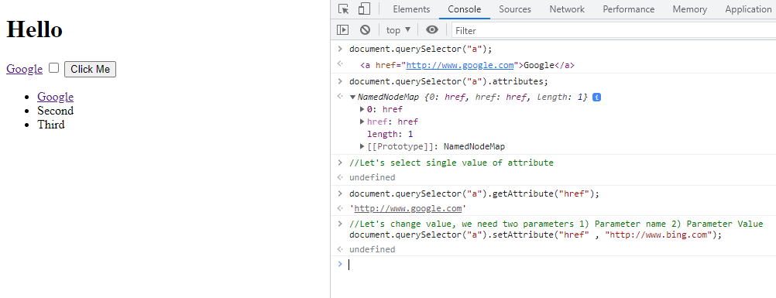

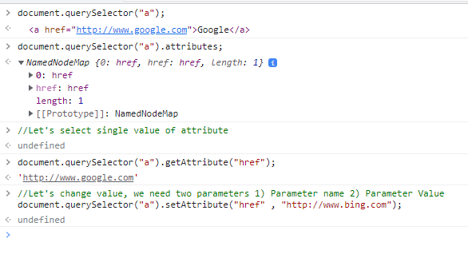

document.querySelector("a");

<a href=​"http:​/​/​www.google.com">​Google​</a>​

document.querySelector("a").attributes;

NamedNodeMap {0: href, href: href, length: 1}0: hrefhref: hreflength: 1[[Prototype]]: NamedNodeMap

//Let's select single value of attribute

undefined

document.querySelector("a").getAttribute("href");

'http://www.google.com'

//Let's change value, we need two parameters 1) Parameter name 2) Parameter Value

document.querySelector("a").setAttribute("href" , "http://www.bing.com");

